A SMART INFANT CRADLE MONITORING SYSTEM

A PROJECT REPORT

Submitted by

DHEVADHARSAN D 2303717610421012
DHIVAKAR B S 2303717610421013
DINESH M 2303717610421014
JIBASH THIYAM 2303717610421026
in partial fulfillment for the award of the degree
of

BACHELOR OF ENGINEERING
in
COMPUTER SCIENCE AND ENGINEERING


COIMBATORE INSTITUTE OF TECHNOLOGY
(Government Aided Autonomous Institution Affiliated to Anna University)
COIMBATORE-641014

ANNA UNIVERSITY: CHENNAI 600 025

APRIL 2026

TABLE OF CONTENTS

CHAPTER NO. | TITLE | PAGE NO.
1 | PROBLEM STATEMENT | 1
2 | COMPONENTS REQUIRED
 | 2.1 SOFTWARE
 | 2.2 HARDWARE
3 | ARCHITECTURE / CIRCUIT DIAGRAM
3.1 BLOCK DIAGRAM
3.2 CIRCUIT DIAGRAM COMPONENTS
3.3 CONNECTION CONFIGURATION
3.4 WORKFLOW PRINCIPLE
4 | SOURCE CODE
5 | SCREENSHOTS
6 | RESULT

CHAPTER 1

PROBLEM STATEMENT
Parents and caregivers often struggle to continuously monitor their infant's well-being, especially during sleep hours or when in another room. Traditional baby monitors only provide raw audio or video feeds, requiring constant human attention and offering no automated assistance. Furthermore, they lack the ability to monitor crucial environmental factors (like temperature and humidity) or physical states (such as tracking if the baby is restless or peacefully still).

There is a need for an intelligent, automated system that can not only detect when a baby is crying with high accuracy but also automatically trigger a soothing mechanism (such as a lullaby) to calm the child. Additionally, the system must monitor the baby's physical movement and ambient room conditions in real-time, alerting parents immediately if the room becomes uncomfortably hot or if the baby requires attention, logging these events securely to the cloud for historical tracking.

CHAPTER 2
COMPONENTS REQUIRED
2.1 SOFTWARE
- Frontend Application: React (with TypeScript), Tailwind CSS for styling, Lucide-React for UI icons and Vite as the build tool.
- Backend Server: Python, FastAPI
- Machine Learning & Audio Processing: TensorFlow Lite (for inferencing the baby_cry_v2_pro.tflite model), Librosa, OpenCV and PyAudio.
- Hardware Communication & Media: PySerial (for reading ESP32 sensor data) and Pygame (for playing the MP3 lullaby).
- Cloud Database & Authentication: Firebase (Firestore for logging cry_log events and Firebase Auth for user profiles).
- Embedded Programming: Arduino IDE (C++).

2.2 HARDWARE
- Microcontroller: ESP32 Development Board.
- Motion Sensor: MPU6050 (6-axis Accelerometer and Gyroscope Module).
- Environment Sensor: DHT11 (Temperature and Humidity Sensor Module).
- Audio Input: Microphone (INMP 441 MEMS Microphone Module)
- Audio Output: Speaker (if required).
- Miscellaneous: Breadboard, jumper wires, and USB data cables.

CHAPTER 3
ARCHITECTURE / CIRCUIT DIAGRAM
3.1 BLOCK DIAGRAM

3.2 CIRCUIT DIAGRAM COMPONENTS

3.3 CONNECTION CONFIGURATION
ESP32 Pin | Connects to MPU6050 | Connects to DHT11 Module | Purpose
3V3 | VCC | VCC (or +) | Provides 3.3V Power
GND | GND | GND (or -) | Common Ground
GPIO 21 | SDA | No connection | I2C Data line for MPU6050
GPIO 22 | SCL | No connection | I2C Clock line for MPU6050
GPIO 4 | No connection | DATA (or OUT) | Digital Data line for DHT11

3.4 WORKING PRINCIPLE
The Smart Baby Monitor operates using a decoupled architecture, split between edge hardware, a local AI server, and a cloud-connected web interface.
- Environmental & Motion Tracking: The ESP32 continuously polls the MPU6050 and DHT11 sensors. It packages the X, Y, Z acceleration data, temperature, and humidity into formatted strings and transmits them over a 9600-baud Serial connection.
- Backend Data Processing: A Python FastAPI backend runs two background threads. The serial thread reads the ESP32 data, calculating the "delta" (difference) in acceleration to determine if the baby is "Moving" or "Sleeping" (stillness for >10 seconds).
- AI Audio Analysis: The audio thread uses PyAudio to capture 5-second overlapping chunks of room noise. Librosa and OpenCV convert the audio waveform into a Mel-spectrogram image, which is fed into a custom-trained TensorFlow Lite model.
- Automated Soothing: If the AI model detects a baby crying continuously for a set threshold (5 seconds), the backend automatically utilizes Pygame to play a soothing lullaby (song.mp3).
- Frontend & Cloud Logging: A React frontend polls the backend's /status API every second. It displays real-time confidence scores, live temperature (triggering a red warning UI if > 30°C), humidity, and movement status. When the frontend detects that the lullaby has started, it fetches the baby's registered name via Firebase Authentication and logs a one-time event to the Firestore cry_log database for parent tracking.

CHAPTER 4
SOURCE CODE
Arduino ESP32 Source Code (sensor_node.ino):
#include <Wire.h>
#include <MPU6050.h>
#include <DHT.h>

#define DHTPIN 4
#define DHTTYPE DHT11

MPU6050 mpu;
DHT dht(DHTPIN, DHTTYPE);

void setup() {
Serial.begin(9600);
delay(1500);
Wire.begin(21, 22);

mpu.initialize();
dht.begin();
}

void loop() {
int16_t ax, ay, az, gx, gy, gz;
mpu.getMotion6(&ax, &ay, &az, &gx, &gy, &gz);

float h = dht.readHumidity();
float t = dht.readTemperature();

Serial.println("----- Sensor Data -----");
Serial.print("Accel X: "); Serial.print(ax);
Serial.print(" | Y: "); Serial.print(ay);
Serial.print(" | Z: "); Serial.println(az);

if (!isnan(h) && !isnan(t)) {
Serial.print("Temp: "); Serial.print(t); Serial.println(" C");
Serial.print("Humidity: "); Serial.print(h); Serial.println(" %");
}
delay(2000);
}

CHAPTER 5
SCREENSHOTS
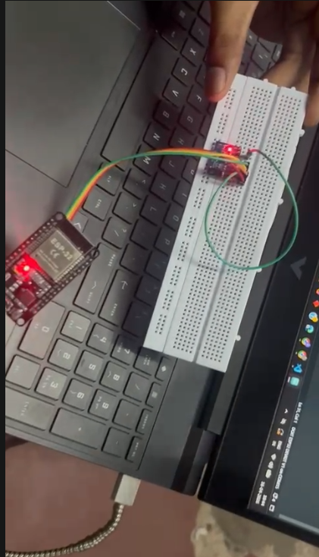
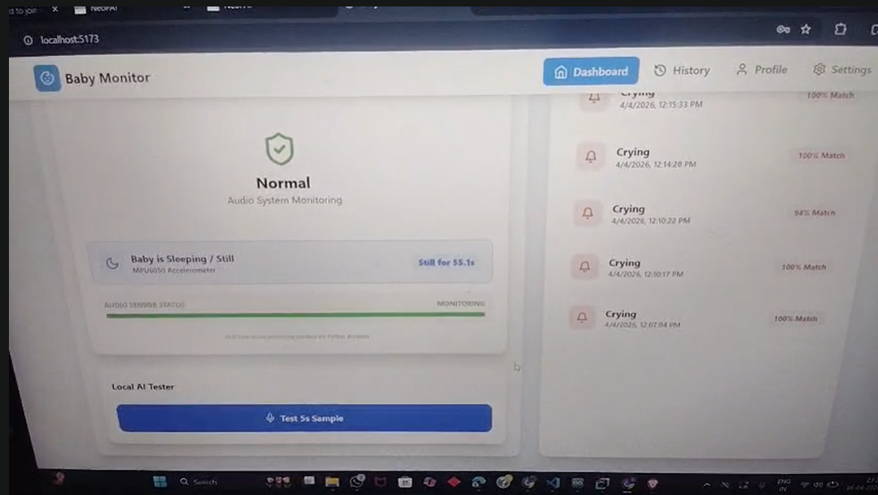

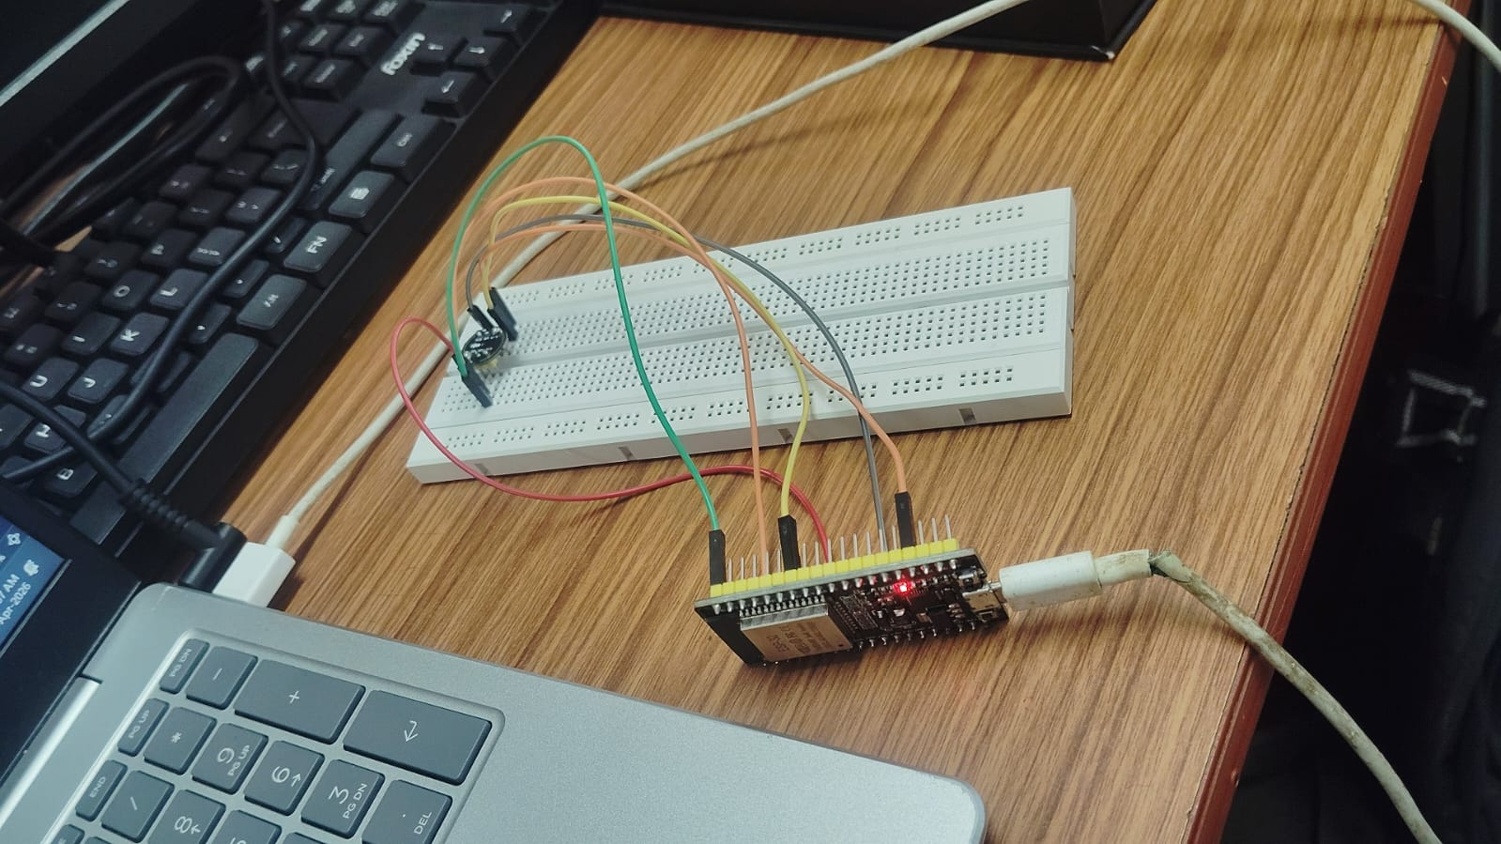

CHAPTER 6
RESULT
The completed Smart Baby Monitor system successfully acts as an autonomous guardian for an infant.
- AI Audio Detection: The system accurately captures room audio, filtering out background noise, and positively identifies a baby's cry with high confidence.
- Automated Action: The soothing mechanism performs flawlessly, reliably playing a lullaby only after a sustained 5-second crying threshold is met, preventing false triggers from brief noises.
- Sensor Integration: The ESP32 smoothly transmits data to the backend. The motion delta algorithm successfully filters out sensor noise, accurately classifying the baby's state as either "Moving" or "Sleeping/Still". The DHT11 integration accurately displays ambient room data.
- UI & Cloud: The React dashboard seamlessly updates in real-time without latency, flashing a visual warning when the room temperature exceeds the 30°C safety threshold. Finally, the system securely communicates with Firebase, accurately attaching the registered baby's name to the cry_log database whenever the soothing system is activated, providing parents with a reliable digital history of their child's sleep interruptions.

